
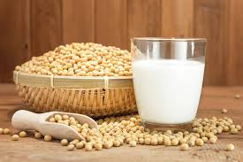
TOPIC
INDEX
Preparation of soybean milk
and its comparison with natural milk with respect to curd formation, effect of temprature, etc.

